Requirements for articles

Articles for the conference proceedings are peer-reviewed.
Article submission and acceptance scheme:

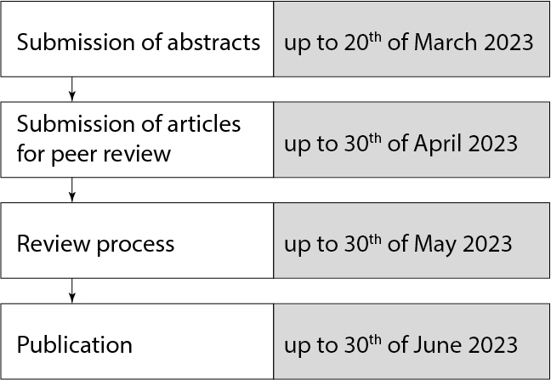

Formatting requirements

Article should be written in Microsoft Word; the text should be typed on an A5 format page, single spaced, using a Times New Roman 10 pt font, justified. All the margins should be 2 cm.

Title 12 pt, centered, Uppercase, Bold
Authors: surname, initial, 10, centered, Bold
Institution 10 pt, centered, Normal
Abstract 10 pt, left, Bold, abstract’s text 10 pt, justified, Normal
Keywords 10 pt, justified, Italics
Sections 10 pt, left, Bold
The main text 10 pt, justified, 1st line indent 5 mm, Normal
Numeration of tables 10 pt, centered, Italics
Numeration of figures 10 pt, centered, Italics
References 10 pt, justified, Normal

TITLE OF ARTICLE
(Times New Roman, 12 pt., uppercase, centered)

Name Surname¹, Name Surname²
¹ Name of the Institution: lowercase 10 pt. letters, in italics, centered
² Name of the Institution: lowercase 10 pt. letters, in italics, centered

Abstract
An abstract should contain a short overview of the article content, problem and the relevance of the research, research methods and the results obtained. The text of an abstract must be clear and concise. The length of an abstract is 300–500 characters.

Keywords: keyword 1, keyword 2, keyword 3, keyword 4, keyword 5. (3–5 keywords expressing the most essential features of the topic should be given under the abstract).

Introduction
The problem of the topic, its relevance and the extent of its exploration, the aim, object and objectives (in case of empirical study) of the research and research methods are formulated.

Methodology and equipment
This part includes a description of the research methodology, software, analysis of the equipment and materials, and research conditions. In the case of an empirical study, the main part should include a discussion of the procedures/methods of the theoretical framework and hypothesis.

Presentation of research results (Analysis)
The most important parts of the analysis section can be:
- Analytical research and problem solutions;
- Research results and discussion.
If the article is theoretical, it is necessary to provide a consistent substantiation of the suitability of the selected sources for the solution of a chosen problem.
At the same time, test conditions, parameters and constraints must be indicated, too. Obtained data should be clearly explained with figures and tables.
Presentation of research results can ranger in length from 5 to 8 pages.

The titles of the figures are given in the example below:
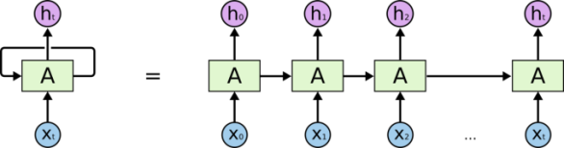
Fig 1. Title of the figure

The titles of tables are given in the example below:

Table 1. Title of the table
Xxxxxx | Xxxx | Xxxxx | Xx
Comparable items | 0 | 0 | 0
Comparable items | 0 | 0 | 0
Comparable items | 0 | 0 | 0
Comparable items | 0 | 0 | 0

Conclusions
- Conclusions reveal structured results.
- In the case of empirical research, highlight the carried-out activities.
- …

List of references
- It is recommended that the included scientific publications should be limited to the last five years, and the number of references should not exceed 10. References have to be listed under the international APA guidelines. The citation of textbooks, brochures, popular magazines, advertising brochures and other similar sources is not allowed.
- In the text of the article, sources are cited in brackets by indicating the author's surname and year of publication, e.g.: (Cooper 2018), (Cleland, Kaufmann 2012). When the author is mentioned in the text, only the year is written in brackets, e.g.: „... as stated by N. Dagėlienė (2020)...“. If the Internet source has no author, the reference is added only in the text in parentheses.
- For example, Ku, G. (2008). Learning to de-escalate: The effects of regret in escalation of commitment. Organizational Behavior and Human Decision Processes, 105(2), 221–232.
- …
- At least 5 references must be cited in the article.

